Bridge Manager | Administration Guide
v 1.3.5



Bridge Manager Server

Prerequisites 1
Microsoft SQL Server Setup 1
Installation 2
Future Updates 2
First Run 2
Quick Setup 3
Reader SQL Login Configuration 4
Customise Network Port Settings 4
Creating and Restoring From Backups 4
Creating a Backup 4
Restoring From a Backup 4
Console Commands List 5
home 5
database 5
data 7
agent 8
network 9
Bridge Manager Client

Prerequisites 10
Installation 10
Future Updates 10
First Run 11
Network Settings 11
Log In 11
Troubleshooting 11
User Account Management 12
Adding a New Account 12
Editing an Account 13
Deleting an Account 13
Resetting a Password 13
Additional Account Controls 13
Database Layout 14
Database Layout Table Summary 14
Adding a New Column 15
Editing a Column 17
Removing a Column 18
Reordering Columns 18
Correcting Change Reasons 19
BridgeManager Database Diagram 20

Bridge Manager Server

Prerequisites
Note that the agent and console applications are fully supported for installation on the same system as the client. If this is your preferred method of deployment, combine the system requirements by selecting the highest requirements and prerequisites from each, and set the server IP address in the client to 127.0.0.1
The Bridge Manager agent and console applications have the following prerequisites:

Minimum System Requirements
- Windows Server 2012 R2
- Intel Xeon Processor X5660
- 8GB RAM
- 40GB Disk Space

.NET 6.0 Runtime x86 or x64 depending on your system
Required by the main Bridge Manager agent and console applications.

C++ 2015 Redistributable x86 or x64 depending on your system
Required by the main Bridge Manager agent and console applications. If your operating system surpasses Windows 10 version 1809 (October 2018 Update) or Windows Server 2019, this should not need to be installed.

Microsoft SQL Server
There are many different versions and flavours of SQL Server, and most should work without issue for Bridge manager. The 2017 and 2022 versions of SQL Server Express have been tested and operate without issue. The most important factor in determining which you should use is compatibility with your operating system, but also consider storage capacities if opting for an Express edition. SQL Server 2008 Express and later comes with a 10GB database size limit, which should be sufficient for almost any use case.

Microsoft SQL Server Configuration
Detailed instructions on how to use SQL Server fall outside the scope of this document as the specific menu layout will be slightly different from version to version. To ensure that SQL Server is set up to facilitate Bridge Manager’s various operations, ensure that the following requirements are met:
- The relevant SQL Server instance is set to use both Windows Authentication and SQL Server Authentication.
- The Shared Memory protocol must be enabled in the SQL Server Configuration Manager for the relevant SQL Server instance.
- The relevant SQL Server service must be set to use the local built-in Windows account in the SQL Server Configuration Manager.
- A reader login needs to be created for the agent to run user-defined SQL statements safely.
  - The server role for the login should be set to public.
  - The login must be mapped to BridgeManager (not possible until after the application has been set up).
  - The login should have only the public and db_datareader roles enabled for the BridgeManager database (not possible until after the application has been set up).
Once these requirements are in place, Bridge Manager should be able to carry out all of its functions relating to SQL Server.

Installation
After all prerequisites have been installed, simply copy the Bridge Manager Server folder to any desired location and create a shortcut to BridgeManagerConsole.exe to place on your desktop or in your start menu. This executable is the entry point to the server-side part of the application, and you will generally launch and interact with the agent from here.
If you wish to have the agent start automatically with Windows, you will want to add BridgeManagerAgent.exe to your startup applications. This executable is stored in the same folder as BridgeManagerConsole.exe. There is no direct user interface for this executable beyond the console application, but it will continuously attempt to connect to SQL Server until the connection can be made.

Future Updates
- Stop the agent through the console (see the database section for a list of commands). Close the console.  - Stop the SQL Server service. This can be done through the SQL Server Configuration Manager for whichever version of SQL Server you have installed. | - Replace the Bridge Manager Server directory with the updated version folder.  - Restart the SQL Server service.  - Restart the agent from the console.

First Run
Run BridgeManagerConsole.exe.
On launch, the console will automatically create a Bridge Manager folder in the current Windows user’s Documents folder, which it will use to store files. Everything besides the application is stored here, including the database itself, making it exceptionally simple to back up and restore the deployment in its entirety if needed. See Creating and Restoring From Backups for further information on this subject.

SQL Server Connection
If your SQL Server instance was named something other than “SQLEXPRESS”, then the console will fail to find it on launch. During launch, the application will have created a file named sql-server-name.txt in “Documents/Bridge Manager/Config Files”. Open it, input the correct name, save the file, and relaunch the console application. If everything was configured correctly, you should be presented with a message stating that the server name has been read and that a connection to SQL Server has been established.
If you are still unable to connect to the database, take another look at the SQL Server Configuration section above, and confirm that everything is in place. The problem is most likely to be that the Shared Memory protocol is disabled for the relevant SQL Server instance, or that the name is wrong in sql-server-name.txt

Console Menu Navigation
Before moving on, it would be best to familiarise yourself with the console’s menu navigation system. When the console application has fully loaded, you will be presented with a ‘home>’ prompt. Type ‘help’ and press enter. You will be presented with a list of commands in white, with explanations in grey. If all or part of a command is displayed in square brackets, this represents a variable part of the command. In this case, to navigate between the home, database, data, agent and network menus, you need to replace ‘[menu name]’ with the one you wish to navigate to.
Type ‘agent’ and press enter to navigate to the agent menu, and then type ‘help’ to pull up a list of possible commands. Below the list of global commands, you will now also see a list of agent menu commands. The ‘status’ command tells us we can use it to see if the agent is running. Run the command. Once the database has been configured and the agent is running, this will also present us with a list of logged in users and their IP addresses.
Navigate to the ‘data’ menu, and then run the help command again. You will note that some of these commands call for either a string or an int to be inserted at the end. A string represents text, and an int represents a whole number. If you read the explanation for ‘import organisations [string]’, you will see that it describes what is required as the string for that command.
Better explanations for all available commands are provided later in this guide.

Quick Setup
Database creation is designed to be fully automated on Bridge Manager. Unless you are importing pre-defined database settings (see database in the Bridge Manager Console section) you should be able to simply follow the process immediately below and move straight on to setting up the client once the SQL Server reader account has been configured (see Reader SQL Login Configuration). If you need to customise the network ports, also look at the Network Settings section.
- Open the console.
- Once you are presented with a ‘home>’ prompt, the application has loaded. Type ‘database’ and press return to enter the database menu.
- Type ‘create database’ and press return.
- Type ‘agent’ and press return.
- Type ‘start’ and press return.
Once these steps are completed, you should be met with a message stating ‘Process started’. At this point, you may need to use your Windows admin permissions to grant the agent access to the network. Once this is done, assuming there are no errors, the agent is now running using the default network port configuration and can be connected to by the client on those ports. Be sure to check the Reader SQL Login Configuration section below before moving on to the client.
If the agent fails to run or the database could not be created, take another look at the SQL Server Configuration steps to make certain that everything is set up correctly. You can also take a look at agent-error-log.txt in “Documents/Bridge Manager” to see if there are any error messages that describe where the failure is occurring.

Reader SQL Login Configuration
You must provide Bridge Manager with the username and password for the reader account you created as part of the Microsoft SQL Server Configuration process outlined earlier in this document. To do this, refer to database > set reader credentials in the Console Command List below.
The stored username and password are encrypted at rest.

Server Network and SSL Configuration
In the console, type ‘set network config’. You will be presented with prompts to enter the desired port (the default is 61152), the SSL mode and the optional SSL certificate thumbprint. The thumbprint is only required if you are using SSL.
SSL certificate generation, distribution and thumbprint retrieval fall outside the scope of this document, but you must ensure that the following non-negotiable requirements are met:
- The certificate must contain the server’s static IP address in the SAN extension.
- The certificate must be considered valid according to Windows’ certificate validation.
- The certificate’s private key must be readable by the user account intended to run the agent.
After setting the configuration, in the console, type ‘parse network config’ to confirm that you have input the desired values into the config file correctly. Assuming this is successful, the agent will pick up the new configuration on the next start.
When configuring the port for use in your firewall settings, note that the Bridge Manager client and agent communicate with each other only over TCP, never UDP.

Creating and Restoring From Backups
Since all of Bridge Manager’s working files are stored in “Documents/Bridge Manager”, including the database itself, the task of either creating or restoring from backups is relatively simple.

Creating a Backup
Make sure to stop the SQL Server service before beginning to prevent data corruption in the backup. This can be done through SQL Configuration Manager.
To create a backup, simply copy the Bridge Manager folder to another drive or directory. Start the SQL Server service again only once the copying has completed.
This will back up all aspects of the server-side application. This includes various configuration files, the database itself, report presets, the agent error log, and any other files responsible for storing client settings server-side.

Restoring From a Backup
To restore from a backup, stop the agent through the console (see the ‘start’ and ‘stop’ agent commands in the Bridge Manager Console section below).
Once the agent has been stopped, simply remove the current Bridge Manager folder from Documents, then copy the previously backed up Bridge Manager folder into the same location (the folder must still be named “Bridge Manager” in order for the console and agent to locate it). If another program is currently accessing the database, SQL Server Management Studio for example, you may need to close this in order to remove the original folder.
Once the backup has been copied back to Documents, restart the agent from the console.
Note that if the ‘delete database’ command was run, SQL Server will have had its record of the database erased, and copying the file back in will not be enough. In this case, simply follow the same process regarding copying the backup into the correct location, then relaunch the console. As part of the console’s startup routine, it will automatically locate the files and recreate the database on SQL Server’s end. You will need to manually reconfigure the reader account with its BridgeManager permissions (see Reader SQL Login Configuration earlier in this section).

Console Commands List
Although the bulk of administration is carried out through the Bridge Manager client, there are some functions that rely on the console, such as database creation, data importing and interacting with the agent. This section serves as a comprehensive list of commands with more detailed explanations than those provided when running the ‘help’ command.

home
exit
Quit the console application. The agent, if started, will remain running in the background and will be picked back up by the console on its next launch.
[menu name]
State the name of the menu you wish to navigate to. Type ‘help’ for a list of available menus.

database
The database menu is used for database creation, modification to the template prior to creation, and deletion. For data importing, see the ‘data’ menu immediately after this section. All the commands available in this menu are only relevant at the point of database creation.
Most commands in this menu were intended to streamline the software development process, and as such are not particularly user friendly, but may prove useful in some cases. All except ‘create database’ can be ignored in any scenario where the database creation is not intended to be repeated, as might be the case in a test or demonstration environment. If the database is only ever intended to be created once on one system, you are better off using the client to customise the database layout after installation. The only exception to this rule is if you want to reduce the Organisation or Asset ID column types from INT to SMALLINT or TINYINT, but be aware that you will not be able to increase these later through the console or client should they prove insufficient, and doing so manually through something like SQL Server Management Studio will prove difficult and may corrupt the integrity of the database if not done correctly.

The type override commands offer a way to customise the data type and VARCHAR lengths before creating the database.
The column addition commands offer a way to predefine a list of columns to add to the organisation, asset, contact, conference, task, visit and document tables.
The friendly name commands allow you to predefine more user-friendly names for columns or names more specific to your use case, for example changing ‘Dial_No’ to ‘IP_Address’. They will then display themselves with this chosen name across the client application, but their actual column names in the database tables will remain unchanged.
Any loaded overrides, additions or friendly names are held in memory and applied during database creation.

create type overrides
This command will generate a type-overrides.txt file in the Config Files folder. See the explanation for ‘load type overrides’ below for instruction on its use.
load type overrides
After running the previous command to create type-overrides.txt, open it in a text editor. Instructions are provided at the top of the file – make sure to read these fully. Note that all lines beginning with “# ” will be ignored when loading overrides from the file. Once you are happy and the file has been saved, run the command.
Any errors will be reported, along with the quantity of types that differed from their currently held values after any previous overrides as opposed to their default values. If you need to know the quantity of types that differ from default types, run ‘reset type overrides’ beforehand. If you do receive errors, refer again to the instructions in the file to make sure everything is formatted correctly.
All loaded overrides will be applied to the database structure upon database creation.
reset type overrides
This command clears the type overrides held in memory, but it will not affect the type-overrides.txt file itself. To reset the file to defaults, simply run ‘create type overrides’ again to overwrite it.
view current types
This command will generate a list of all columns and their types with any overrides applied. This will display updated types where overrides are in place but will not display any loaded column additions or friendly names.
create column additions
This command will generate a column-additions.txt file in the Config Files folder. See the explanation for ‘load column additions’ below for instruction on its use.
load column additions
After running the previous command to create column-additions.txt, open it in a text editor. Instructions are provided at the top of the file – make sure to read these fully. Note that all lines beginning with “# ” will be ignored when loading additions from the file. Once you are happy and the file has been saved, run the command.
Any errors will be reported along with a summary of the columns that were found and added. These columns will be included in the database structure upon database creation. Note that, unlike type overrides which accumulate across loads, column additions are automatically wiped prior to each load.
wipe column additions
This command clears all previously loaded column additions from memory. It does not affect column-additions.txt.
create friendly names
This command will generate a friendly-names.txt file in the Config Files folder. See the explanation for ‘load friendly names’ below for instruction on its use.
load friendly names
After running the previous command to create friendly-names.txt, open it in a text editor. Instructions are provided at the top of the file – make sure to read these fully. Note that all lines beginning with “# ” will be ignored when loading friendly names from the file. Once you are happy, run the command. Any successfully read names will be summarised here and will be applied automatically after database creation (all friendly names are held in a dedicated table rather than being applied to the actual database structure in any way).
Note that this command automatically clears any friendly names already held in memory before running.
wipe friendly names
This command clears all previously loaded friendly names from memory. It does not affect friendly-names.txt.
create database
This command will automatically create the database, placing both the BridgeManager_Data.mdf database file and the BridgeManager_Log.ldf log file into “Documents/Bridge Manager”, applying any loaded type overrides, column additions or friendly names as it does so.
Any errors displayed here could indicate an issue with either the SQL Server setup or your Windows account credentials. Ensure that your Windows account has administrator rights, and that SQL Server is configured as per the requirements listed in the Microsoft SQL Server Setup section earlier in the document. Errors displayed in the console simply echo SQL Server’s own error messages, so you may use these to seek guidance from the wider SQL Server community.
delete database
If you wish to delete the database in its entirety, run this command. As this command is highly destructive, you must enter a sequence of strings to confirm deletion. The strings in order are:
11A 11A2B 1B2B3 000DESTRUCT0
Database deletion is completely irreversible unless a backup was made beforehand.
set reader credentials [string]
Set the username and password for the user account, separated by the pipe | symbol. These credentials are encrypted at rest.

data
The commands in the data menu are used to either populate the database with test data for demonstrative, trial or debugging purposes, or to migrate data from another system. Data importing is only possible for the organisation and asset tables, and the database must already have been created.
To get a feel for how it works, first generate random test data using the ‘generate test data’ command. Examine the generated file in a spreadsheet viewer. If you wish to import data of your own, replicate this format exactly, adding or removing columns as needed. Note that at the time of writing this document for Bridge Manager v 1.0, only TEXT, NUMBER, and DATETIME types are fully supported for data import.
In case of import errors, the console application will produce a file in the same folder as the data import CSV file with a ‘-import-errors’ suffix, stating SQL Server’s error message for each failure. This is the best place to start when troubleshooting.

import
This command automatically runs the four commands given below in sequence, assuming file names of ‘Organisations.csv’ and ‘Assets.csv’ located in “Documents/Bridge Manager/Data Import”.

import organisations [string]
State the file name you wish to import and run the command. No full file path is necessary, and the .csv file must be located inside the “Documents/Bridge Manager/Data Import” folder. You will be presented with a series of colons, with red colons indicating failures and green colons indicating successful imports.
After running, any organisation parents will need to be imported using the command below.
import organisation parents [string]
Organisations contain a column representing the parent organisation that they belong to. This can’t be set in the initial data import as the complete list of organisations isn’t yet present in the table, meaning they can’t yet be stated as parents. For this reason, parents must be set after the initial import.
State the same import .csv file you used when running the ‘import organisations’ command, and you will see a similar output indicating failures and successes.

import assets [string]
Identical in nature to the ‘import organisations’ command above, relating instead to assets.
import asset parents [string]
Identical in nature to the ‘import organisation parents’ command above, this time relating to assets. Note that the asset parent column points to organisations rather than other assets.
Importing asset parents has been kept separate from the initial asset import due to the need to avoid import failures in cases where referenced organisations are not present. For this reason, if you wish to avoid importing assets where their parent organisations are not present, you will need to handle this beforehand when preparing your data for migration or handle it afterwards through the Bridge Manager client application.
generate test data [int]
Generate an Organisations.csv file and an Assets.csv file in “Documents/Bridge Manager/Data Import”, each containing randomly generated test data. The int value represents the number of organisations to generate, but bear in mind that for each organisation, up to ten assets will also be generated.

agent
This menu contains a small set of functions for controlling the agent application.
Note that when the console first loads, it will display a message stating whether the agent is already running.
start
Start the BridgeManagerAgent.exe program. Note that this executable must be in the same directory as the console application. The command will fail if the executable could not be found, or if the process is already running in the background.
A difference when the launching the agent from the console as opposed to running BridgeManagerAgent.exe directly from the Windows file explorer is that it will not display an empty console window. You will still be able to find the application in the Windows task manager.
stop
Stop the BridgeManagerAgent.exe program. This command will work even if the agent wasn’t started this session or from within the console.
status
Check whether the agent is already running. If it is, you will also be presented with a list of currently open sessions, with usernames and IP addresses against each.
In case of errors or unexpected behaviour, have a look in “Documents/Bridge Manager” for agent-error-log.txt. This will provide further context for troubleshooting.
logout [string]
Log out a user with an open session. State the username.
close [string]
Close the Bridge Manager client application on a user’s system by stating the username associated with an open session.
Note that this function can be unreliable due to its dependence on the client application being logged in and responsive.
reset admin password
Reset the default admin account’s password to ‘admin’.
open error log
Open the text file containing the server’s error log in the system’s default text editor.
set session cull timeout
Set the session cull timeout in seconds to any value greater than 10. Set to 0 to disable the feature.

network
This menu provides a couple of commands necessary for assigning custom network ports for the agent application to use to communicate with the client. For more detailed instructions, see the Customise Network Port Settings section earlier in the document.
The agent will need to be restarted using the ‘stop’ and ‘start’ commands in the agent menu for any changes to take effect.

set network config
Set the port (the application default is 61152), SSL mode, and SSL thumbprint if required.
parse network config
Test the validity of network-config.txt located in “Documents/Bridge Manager/Config Files”. Assuming the file is present and formatted correctly, you will be presented with the configured ports.
create network config
Create a fresh network-config.txt file in “Documents/Bridge Manager/Config Files”.
open network config
Open the text file containing the network configuration in the system’s default text editor.

Bridge Manager Client

Prerequisites
The Bridge Manager client application requires the following runtime libraries to run:

Minimum System Requirements
- Windows 10
- Intel Core i5-6500 Processor @ 3.60 GHz
- 4GB RAM
- 50MB Disk Space
- 1080p Display Resolution

.NET 6.0 Runtime x86 or x64 depending on your system
Required by the main Bridge Manager client application.

Installation
Simply copy the Bridge Manager Client folder to any desired location and create a shortcut to "Bridge Manager.exe" to place on your desktop or in your start menu.
After being run for the first time, the program will automatically create a Bridge Manager directory in your Documents folder in which to store the network settings. Currently there are no other files held here, but any future updates will make use of this directory whenever the program needs to utilise the system's storage.

Future Updates
Due to the rudimentary nature of the installation, updates follow a similar process. Simply overwrite the current installation with a folder holding the latest version of the Bridge Manager client.
Bridge Manager must be closed before attempting the update. Note that if the application is hosted on a shared drive, all users will need to close Bridge Manager on their systems. The Close Client instructions in the Additional Account Controls section could assist with this if users have not left the application running while logged out.

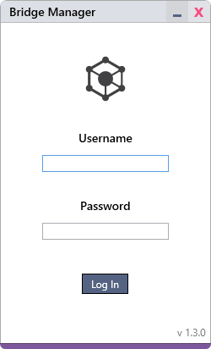
First Run
When launching the application, you will be presented with the login window.

Network Settings
To connect to the agent, you will need to set the server IP address and the desired ports.
Open Network Settings. To do so, click the Login button while holding down Ctrl-Alt-Shift. While holding the keys down, the button will change from Login to Network Settings.

IP Address
Set this to the IP address of the server that hosts the Bridge Manager agent.
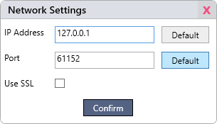
Port & Use SSL
These settings must mirror the agent’s network configuration.

Log In
Once the network settings have been set, log in with the built-in administrator account. The default username and password will be 'admin' and 'admin'. It is recommended to change this password as early as possible.

Troubleshooting
Unable to login
If you are unable to log in using the default admin credentials, use the console application on the server to reset the admin password.
Unable to connect to agent
If you are unable to connect to the agent, then the IP address, port, or SSL settings may be incorrect. Check the client's network settings and the agent's network-config.txt file, and make sure they mirror each other. If you are still unable to connect, it could indicate an issue with your network, firewall, or SSL certificate configuration. Confirm network connectivity on both ends, that the selected port is open for TCP connections on the client and server machines for the Client and Agent applications respectively, and confirm that the SSL thumbprint, if in use, is specified correctly in the network-config.txt file with no trailing white space.
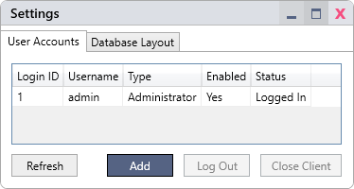
User Account Management
To manage user accounts, go to the User Accounts tab in File > Settings.

Adding a New Account
- Click Add.
- Input the desired username and password. Note that there are no restrictions on password complexity.
- Set the user’s permissions, referencing the information below if required.
- Enable or disable the account as needed.
- Click Save.

Permission Categories
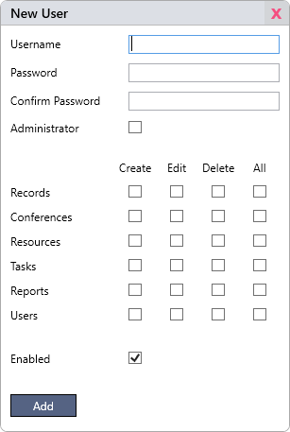
Administrator
Checking this box will hide all other permission categories, since full administrators hold all rights implicitly. As well as all permissions listed below, they have the following capabilities:
- Correct change reasons in the change logs of organisations and assets.
- Forcefully log out users and close clients remotely.
- Alter the database layout.

Records | Relates to organisations, assets, and contacts and bank holidays.
Conferences | Relates to conferences, connections and recurrences.
Resources | Relates to resources.
Tasks | Relates to tasks, visits and documents.
Reports | Relates to presets for the Select Query Builder, Select Statement, and Report to Templates tools.
Users | Relates to user accounts.

Create, Edit, and Delete
Each category (i.e. records, conferences, resources, etc.) is split out into ‘create’, ‘edit’ and ‘delete’ permissions. In most cases these functions are self-explanatory, but some examples require more explanation and a partial understanding of the database layout.
Essentially, any action that causes a change to any entity, such as a login, record or conference, requires the relevant ‘edit’ permissions. This can mean that some things that seem like they should be creations or deletions are in fact treated as edits. This can result in some unexpected behaviours, such as when removing an asset from an organisation. This is not a deletion, because no entities are being deleted. Here, the asset is being automatically edited to set its Parent Reference field to null, making this a record edit.
Some actions require more than one of the three permission types to carry out. One example would be when creating a new recurrence by right clicking on a conference in the schedule view. This is both a creation and an edit, as the recurrence must be created, and the conference must be automatically edited to reference the new recurrence.
Although it may seem confusing in some instances, this approach allows for complete consistency in how each permission type is treated in every instance across the application.

Enabled
This setting is used to disable and re-enable accounts if required.

Editing an Account
- Double click on any account listed to bring up the User Settings window. Note that some settings cannot be changed on the built-in admin account.
- Make any desired changes and click Save (not necessary after a resetting a password).
- If the user is currently logged in, changes will not take effect until they log out. It is strongly recommended to log a user out remotely if they are logged in when changes are made.

Deleting an Account
- Double click on any account listed to bring up the User Settings window. Note that the built-in admin account cannot be deleted.
- Click Delete.
Note that deleting a user account will cause associated record changes and conferences to list the user as [user deleted].

Resetting a Password
- Double click on any account listed to bring up the User Settings window.
- Click on Reset Password
- After a password has been chosen and repeated in the Confirm field, click Set Password.
- Close the User Settings window. There is no need to click Save unless other changes have been made.

Additional Account Controls
Log Out
Remotely log a user out. This is especially important if you have just made changes to a user’s permissions.
Close Client
While a user is still logged in, you have the option to close their client application remotely. This can be useful if the Bridge Manager client is hosted on a shared drive, and you need all users to close their applications before you can update the software.
Note that this function can be unreliable due to its dependence on the client application being logged in and responsive. It may take up to 10 seconds for the session to be closed. Click Refresh to check the user’s status.
Database Layout
To manage the database layout, go to the Database Layout tab in File > Settings.
Note that these settings should only be changed by an administrator with a good understanding of Bridge Manager’s database layout, and also of SQL databases in general.
Click Refresh at any point to reflect any changes made. Changes you make should be reflected immediately, but the column list may be out of date if another administrator is currently working on the database layout.

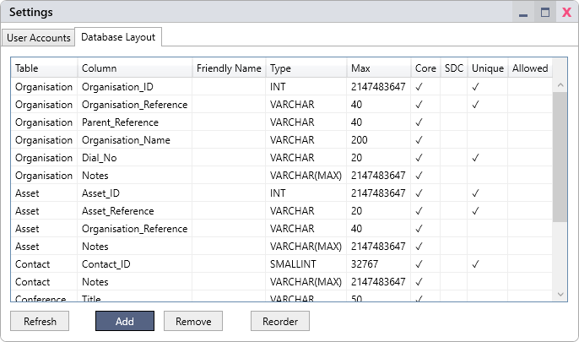

Database Layout Table Summary
The Database Layout tab contains a summary of every column in the database that relates to the Organisation, Asset, Contact, Conference, Task, Visit, Document, Login or Recurring tables.
Table
The table the column belongs to.
Column
The name of the column.
Friendly Name
Non-editable columns that are integral to the software’s core functions may use friendly names to change how they appear across the application. See the Adding a New Column section for more details and Editing a Column for changing the name of non-core columns.
Type
The SQL data type of the column.
Max
Either the maximum length of a text field, or the maximum value of a numerical field.
Core
If a column is marked core, then it is integral to the running of the application and will have some settings unavailable for edit.
SDC
User-added columns may have ‘soft duplicate checks’ enabled to reduce the risk of data duplication. See the Adding a New Column section for more details.
Unique
User-added columns may have a unique SQL constraint placed on them to eliminate the possibility of data duplication.
Allowed
This list of values, if present, represents what will appear in the associated dropdown list wherever this column appears in the application. This will only ever appear on columns of VARCHAR type.

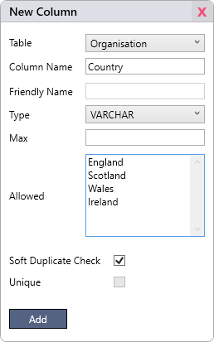
Adding a New Column
- Click Add in the Database Layout tab.
- Select the database table to which you would like to add the column.
- Input an SQL-compliant column name.
- Select type, along with the maximum length/value and allowed list if necessary.
- Select Soft Duplicate Check or Unique if required.
- Click Add.

Table
Select the table to which you would like to add the column.
Column Name
The column name must be SQL-compliant. Any spaces will be automatically replaced with underscores for compliancy, and throughout the application the column name will have its underscores replaced with spaces for better presentation.
Friendly Name
For the non-editable columns that are integral to the software’s core functions, you may set a friendly name. In most instances, these will be displayed wherever they appear across the application’s various windows. For example, if you set the friendly name for the organisation table’s Dial_No column to ‘IP Address’, it will appear as ‘IP Address’ in the Organisation window, the search bar of the data pane and the select query builder.
Note that friendly names, like column names, are stored in the database with spaces replaced with underscores. When displayed in the application, the underscores are replaced with spaces for better presentation.

Type
A selection of SQL data types is available for use in Bridge Manager. Reference the following list of types to select one that meets your needs.
VARCHAR
Variable-length text type (VARiable CHARacter). This option should be used whenever you wish to place a maximum length on a text field using the Max field, or whenever you wish the field to be displayed as a dropdown list. Note the Max value must equal or exceed the length of the longest option in the allowed list.
VARCHAR(MAX)
Unlimited-length text type. This option should be used whenever you wish to store text data of unknown length. Note that this option is no less efficient in terms of storage space than the previous VARCHAR option when storing shorter strings. It simply allows for up to 2^31-1 characters’ worth of text in the field.
VARCHAR(MAX) columns may not have an associated allowed list.
TINYINT, SMALLINT & INT
Whole-number types. Each has a different maximum value, displayed in the Max field.
DATE, DATETIME & TIME
Types for storing the date only, the date and time, or the time, respectively. Note that the TIME type cannot exceed 23:59. This is an unfortunate limitation of Microsoft SQL Server, and there is no TIMESPAN type available in SQL.
BOOLEAN
Tue/false data type, representing SQL Server’s BIT type. It is displayed in most parts of the application as a dropdown list with the options of NULL (blank), ‘Yes’ or ‘No’.
Max
This field is only editable for the VARCHAR type. If you are intending to use the allowed list, the max setting must equal or exceed the length of its longest string. For other types, this field represents the maximum length or value of the respective type.
Allowed
This field can only be used with the VARCHAR type, and if it is used, it represents the options that will display in the dropdown menu wherever this column appears in the application. If the allowed list is left empty, then the column will display as a simple text input field.
The list of options should be separated by line breaks. Make sure not to leave a trailing line break at the end, as this would add an empty option to the end of the dropdown list. An empty option is already present by default, always appearing at the top of the list, and is stored as NULL if selected.
Soft Duplicate Check
Placing a soft duplicate check on a column is a great way to reduce the risk of accidental data duplication, without enforcing uniqueness with a unique constraint (see below). If this setting is enabled, then whenever a user attempts to create or make a change to a record or conference, they will be alerted if an identical value already exists in that column. They can then either bypass this warning or go back to take a closer look.

Unique
This setting is disabled when creating a column and must be set after creation (see Editing a Column).
Placing this constraint on a column will force all of its values to be unique. It cannot be bypassed, is enforced by SQL Server, and cannot be placed on a column that already contains duplicate values until this has been resolved.
Note that the constraint only affects duplicate non-NULL values. Multiple NULL values are still allowed in the column.

Editing a Column
Note that only user-added columns are completely customisable. All other columns are core to the software, and only customisable fields are enabled.
- Double click the column you wish to adjust.
- Adjust as needed.
- Click Edit to save any changes.

Editing Core Columns
While making changes to core columns is allowed, it is only recommended in most circumstances to set a friendly name if desired. While the column type or max length is often partly editable (numerical columns are locked to the various INT types; textual columns are locked to either of the VARCHAR types), these changes should only be made if the need arises. It is, for example, possible that you could run out of ID values in a column of TINYINT or SMALLINT type. If this occurs, the type should be changed to raise the max value. Likewise, the VARCHAR length should be increased if you start working with organisation or asset references that exceed the current max character length.
Some columns are primary keys that must be kept synchronous with any foreign keys that reference them. Bridge Manager has been designed to automate this process, so that, for example, if Organisation.Organisation_Reference has its max length updated, then Asset.Organisation_Reference and Organisation.Parent_Reference will be automatically updated to reflect this.
Making changes to columns that would result in any of their held values being invalid is strictly disallowed by SQL Server.
Even with these safeguards in place, it is advised to leave core column types alone unless absolutely necessary, and to always back up the database before making any changes.
If you need to change the INT type of a primary key column, note that all unique constraints must be lifted from the relevant table beforehand due to a quirk in the way SQL Server implements non-clustered indexes. Incidentally, this makes changes to the organisation and asset ID types impossible as there are built-in unique constraints on these tables.

Type Conversions
How SQL types are converted, and which SQL type conversions are possible, falls outside the scope of this document. It is enough to note here that the application allows for changes to the column type within the bounds of SQL Server’s implementation, such as between BOOLEAN and TINYINT, but you should be extremely careful when doing this and should always create a backup beforehand to prevent data loss.

Removing a Column
Only user-added columns can be removed from the database. Always back up the database before carrying out a removal to prevent accidental data loss.
- Click on the column you wish to be removed.
- You may be presented with a warning if the column contains any data.
- Click Remove.

Reordering Columns
To rearrange the order in which user-added columns are displayed across the application, click Reorder in the Database Layout tab in File > Settings.

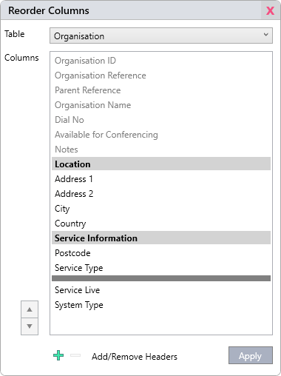
Moving a Column
- Select a table.
- Select any user-added column (core columns are greyed out). You may select more than one by holding the shift key.
- Click the ▲ or ▼ buttons to move the column(s) up or down.
- Add headers and separators as desired (see below).
- Click Apply.

Headers & Separators
Headers are handy for making the data input areas more readily discernible and intuitive. They will appear in the organisation, asset, contact and conference windows.
- Click to add a new header. You will see a new header appear in the column list. Headers are identified in bold with a grey background.
- Double click it to name it.
- Click the ▲ or ▼ buttons to move the header up or down.
- Click to remove the header if desired.
To convert a header to a separator, simply double click on it, delete the header name, and click Confirm. You will notice that it becomes an empty narrow row in the column list. Control or remove it in the same way as a header.

Note on Order Storage
Headers and separators are stored in “Documents/Bridge Manager/Config Files/section-headers” on the server. The column orders are stored in the OrganisationOrder, AssetOrder, ContactOrder, ConferenceOrder, TaskOrder, VisitOrder and DocumentOrder tables in the database.
Correcting Change Reasons
Bridge Manager accounts with full admin rights have the capability to correct change reasons. This capability is restricted to administrators in order to maintain the integrity and reliability of the change logs associated with organisations and assets.

A Brief Explanation of the Change Tables
Only the organisation and asset tables have change logs associated with them. They are intended to track past versions of their associated records. These past versions are fully searchable and can be viewed as snapshots in time from within the client application.
On a data level, the organisation and asset tables each have a separate change table associated with them. Each row of these tables stores the changes that were made in any given edit, with every column that wasn’t changed holding a NULL value. Each column has a BIT column alongside it to determine if the value was or wasn’t changed. This makes the system rather efficient regarding storage, since the entire organisation or asset is not recreated fully in each snapshot.
When a user wishes to view a past version of a record, the agent takes the row that corresponds to the desired date and time and works backwards to build up a picture of what the record looked like at that point. If updates are made to either the organisation or asset table via the client or console, the associated change table is updated to reflect this.
Due to the way reconstruction takes place, a change can and must never be deleted or have its time adjusted, as this could result in operational errors within the software when viewing previous versions of the organisation or asset. Only the change reason can be corrected. Also, since Bridge Manager maintains the change tables according to its own implementation, the Organisation and Asset tables should never be altered using SQL and should only be edited from inside the application to ensure the change tables are kept in check.
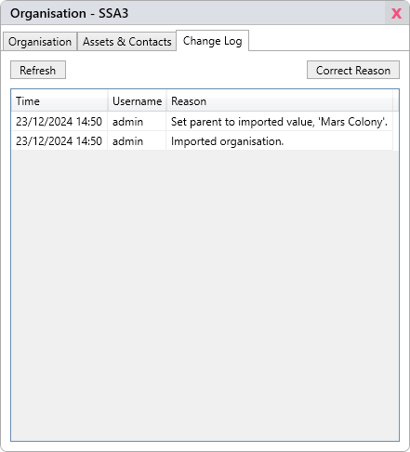
Note that the organisation and asset tables still hold complete records – only the change tables contain fragments of records. If you were to view the most recent change snapshot for a record, you would find it to be identical to the complete record stored in the organisation or asset table.

Correcting a Change Reason
- Open any existing organisation or asset.
- Click on the Change Log tab.
- Select a change from the list.
- Click Correct Reason.
- Correct the old reason, or type in a new one.
- Click Submit.

Click Refresh to reflect any changes made to the record since you first opened the window.

BridgeManager Database Diagram
Note that the diagram below is not exhaustive, as it omits the OrganisationOrder, AssetOrder, ContactOrder, ConferenceOrder, TaskOrder, VisitOrder, DocumentOrder and FriendlyNames tables. Those tables are purely operational to the application and are not intended to be queried by the user or administrator.

